09.2.1
DEPARTMENT OF NEUROLOGY NO.1
RE-EXAMINATION SCHEDULE for the academic year 2024-2025, semester I,
FACULTY OF MEDICINE NO. 2, IVth year

Date | Time | Exam | Auditorium
19.02.2025 | 14.00 | Oral | Department of neurology no.1,  2 Korolenko str., bloc II, of.110/108/104
19.02.2025 | 15.00 | Test | "Leonid Cobileanski" Didactic block no. 1, 27 Nicolae Testemițanu str.

Șef studii, conf. univ. 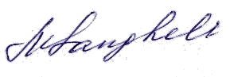 Marina SANGHELI

